**Assignment 1:**

Create a passport size image and arrange the multiple copy of the  same image on the A4 size page.

Before image:

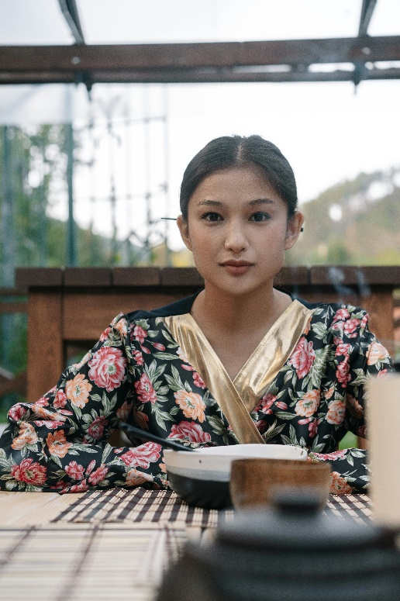

Steps:

Remove background

* Open the image.
* Crop the image if necessary.
* Select Quick Selection Tool (left menu list) and use it to select the fore ground.
* Use “Brush +”, “Brush -“ and “Brush size selector” opetions of Quick Selection Tool (top menu list) to respectively select, deselect portion of image and change brush size.
* After the image is selected, Right Click on the image and select “Select Inverse”, to select the back ground.
* Right Click on the image and select “fill”, use: color, white.
* Right Click on the image and select “Select Inverse”, to select the fore ground.
* Right Click on the image and select “refine edge” and adjust edges.

Make passport size (3.5cm x 4.5 cm)

* Select crop tool, set aspect ratio 3.5 x 4.5, and crop it.
* Go to Image -> Image size, set the following,
  + Width = 3.5 cm
  + Height = 4.5 cm
  + Resolution = 1000 pixels per inch
* Go to Image -> Canvas size, set the following,
  + Width = 3.55 cm
  + Height = 4.55 cm
  + Set a background color, Gray, to give the image a nice border.
* Create a new image (ctrl + n), set the following,
  + Width = 16 cm
  + Height = 20 cm
  + Resolution = 1000 pixels per inch
  + This image will hold 16 copies of passport size images.
* Select the image (ctrl + a), copy it (ctrl + c) and paste it (ctrl + v) on the new image. Which will create a new layer (say, layer 1) on the background of new image.
* Make background invisible, that makes moving the passport size image easier.
* Move the passport size image (layer 1) to the top left corner of the frame.
* Make multiple copies of this passport size image,
  + Right click on layer 1 in list of layers.
  + Select Duplicate layer.
  + Create one duplicate layer.
  + Drag and place the new (duplicate) layer image beside layer 1 image in the frame
  + Thus, 2 copies of that image is created.
* Now, marge these two layers,
  + Right click on layer 1 in list of layers
  + Select Marge Visible.
* Repeat last 2 steps until we have 16 copies of passport size images in the frame.
* Save your master piece.

After image:

Background removed

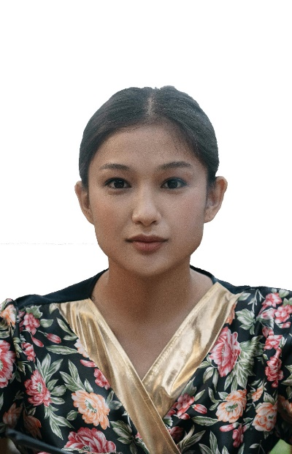

Single passport size photo

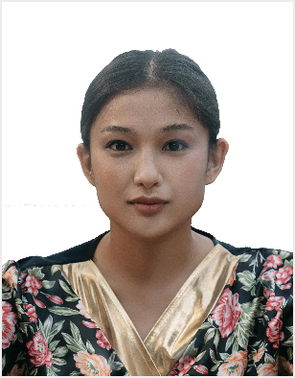

Passport size photos in A4 page

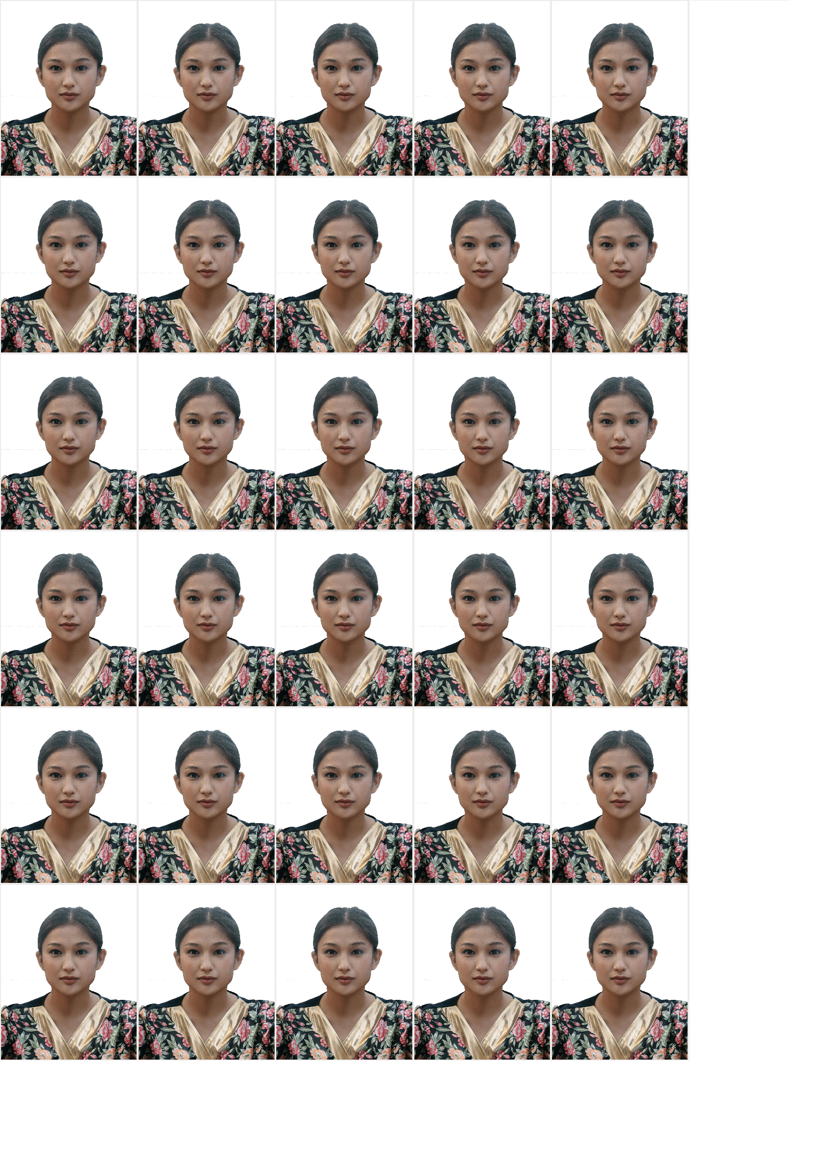

**Assignment 2:**

Change the colour of the particular portion of the image using hue saturation.

Before image

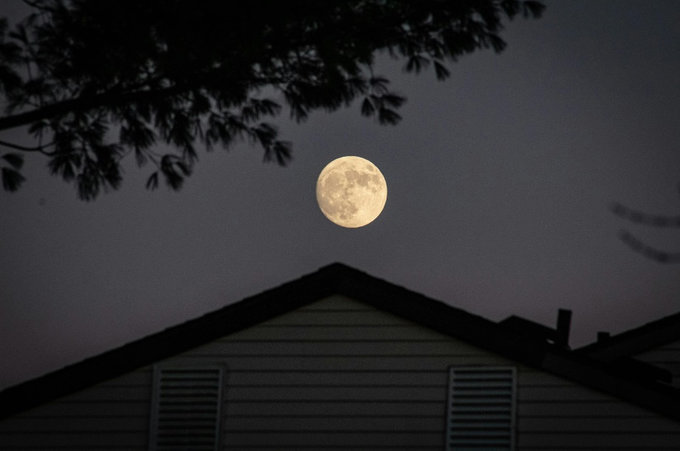

Steps

* Open an image.
* Select Quick Selection Tool (left menu list) and use it to select the fore ground.
* From “Create New Fill or Adjustment Layer” (bottom right, below list of layers) select Hue/Saturation Option.
* Adjust the intensities of the colors accordingly.
* Save your master piece.

After image

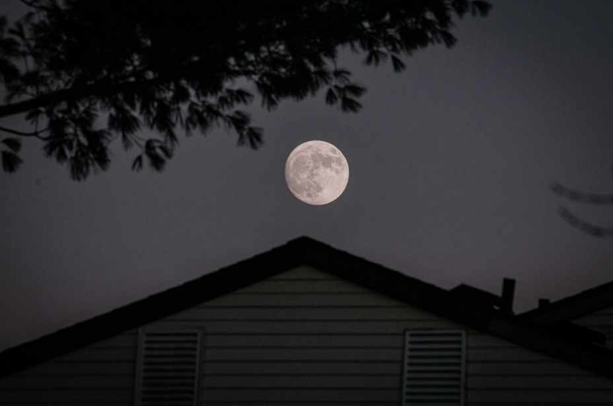

**Assignment 3:**

Remove the background of the image and put the image on a new  background.

Before image:

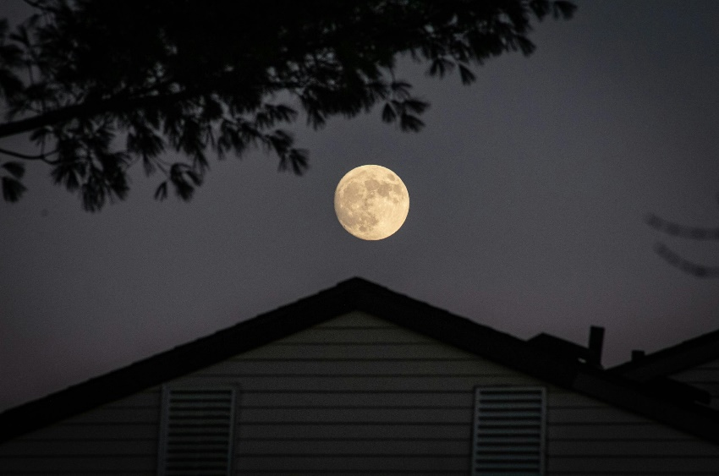

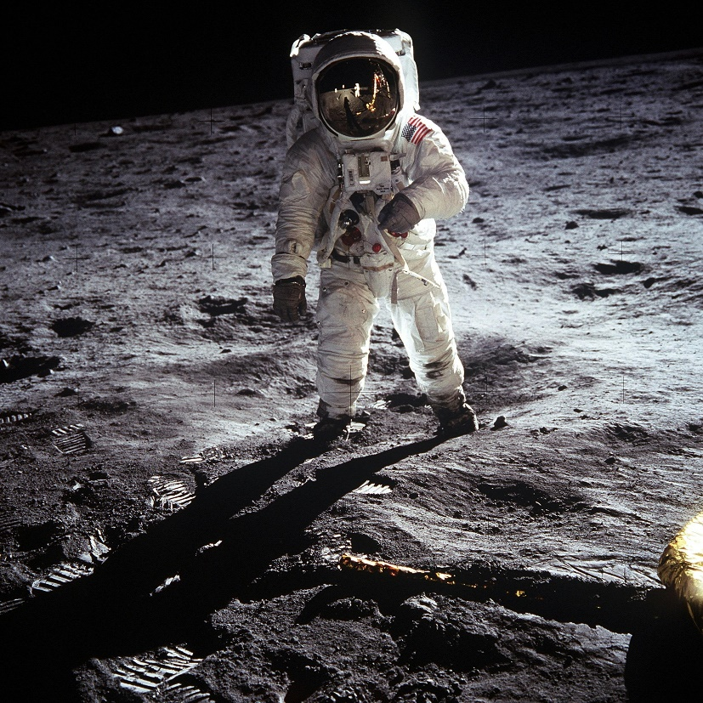

Steps:

* Open both the images.
* Select the object from source using “Quick Selection Tool”.
* Use “ctrl + j” to create a new layer containing the selected image only.
* Using move tool (left menu list) drag it on the target image tab and place it on the desired place in target image, it will become a new layer (say, “layer 1”) in the target image.
* Select layer 1 (i.e., dropped image) and select “Rectangular Marquee Tool” (left menu list).
* Right click on the image and select “Free Transform” and change its shape is needed.
* Save your master piece.

After image:

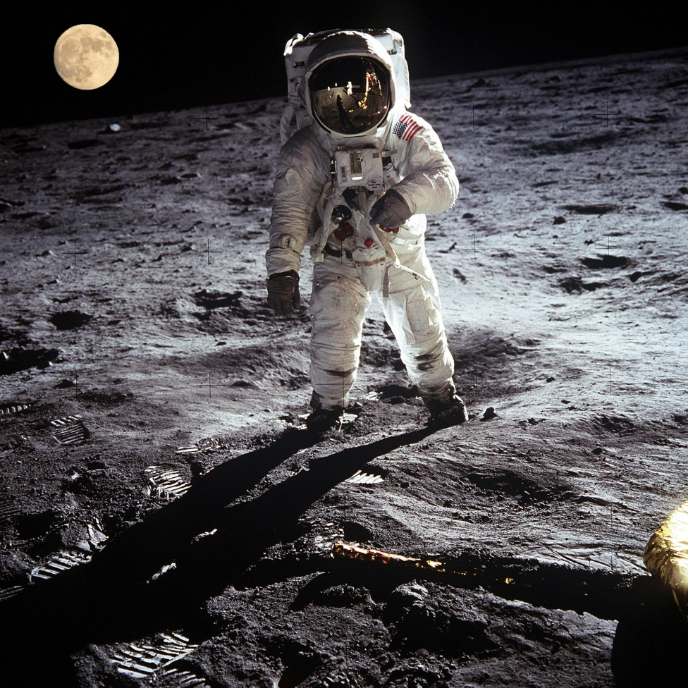

**Assignment 4:**

Convert a color image to Black and white.

Before image:

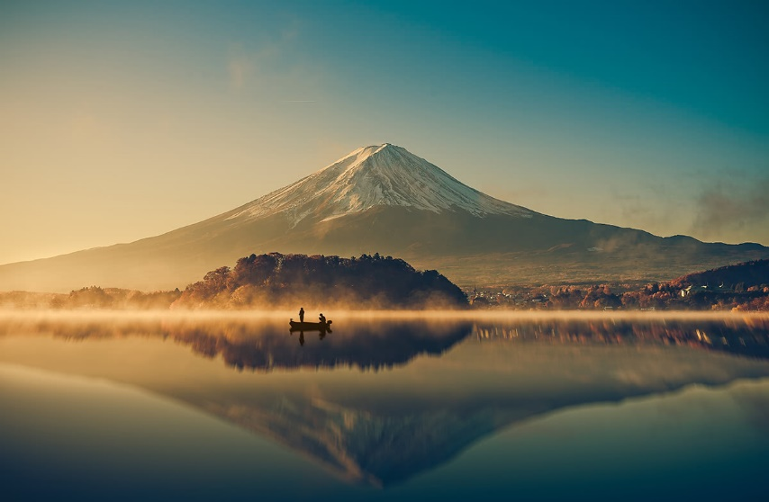

Steps:

* Open an image.
* Go to Image -> Adjustments -> Black & White, a pop up box opens.
* Adjust the colors (if needed) and click OK.
* Save your master piece.

After image:

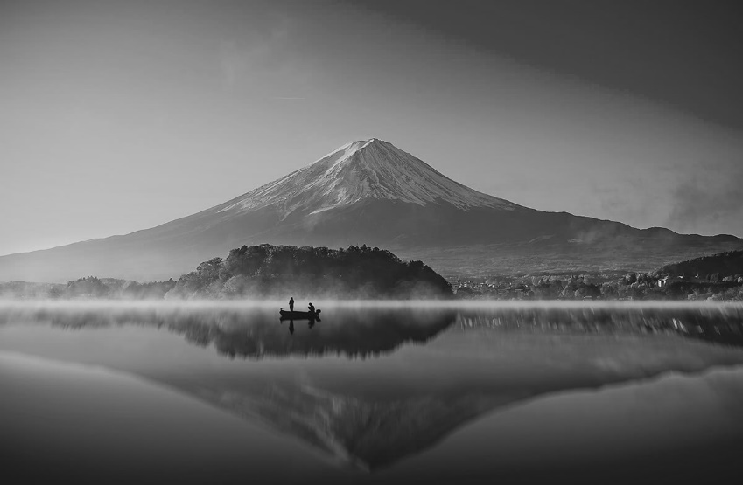

**Assignment 5:**

Using clipping mask technique insert an image within a shape.

Before image:



Steps:

* open the image
* Select image layer (marked as background), Go to layer option, go to new, select layer from background, Set the background image as layer0.
* Select the ellipse tool (or any other custom shape tool, left menu list) and select the portion of the image that is to be clipped, this will create an ellipse layer.
* Now, go to layers list and drag the ellipse layer below the layer0 (image layer) to get the image behind the ellipse.
* Right click on layer0 and select clipping mask.

After image:



**Assignment 6:**

Remove unwanted objects from the image.

Before image

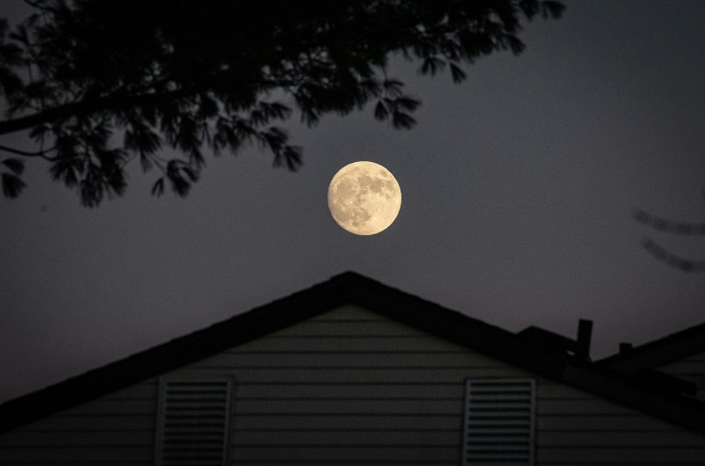

Steps

* Select object of the image to be removed using Spot Healing Brush (left menu list, looks like a band-aid).
* Save your master piece.

After image

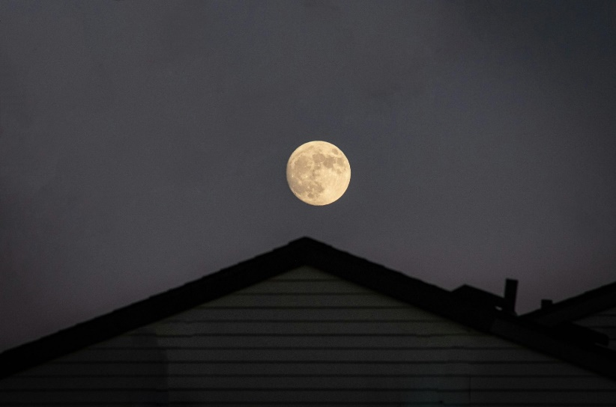

**Assignment 7:**

Create blur background of the image.

Before image

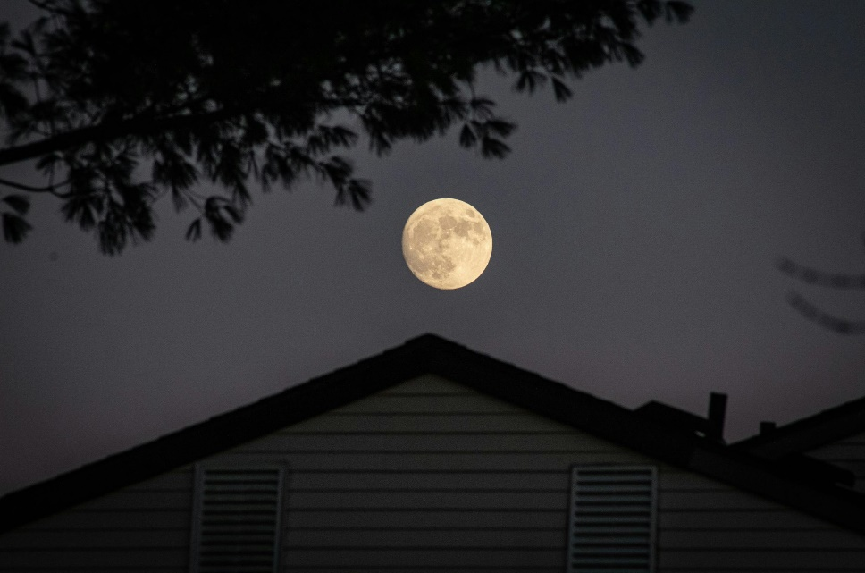

Steps

* Open an image.
* Select Quick Selection Tool (left menu list) and use it to select the fore ground.
* Use “Brush +”, “Brush -“ and “Brush size selector” opetions of Quick Selection Tool (top menu list) to respectively select, deselect portion of image and change brush size.
* After the image is selected, Right Click on the image and select “Select Inverse”, to select the back ground.
* Go to Filter -> Blur -> select Gaussian Blur.
* Adjust blur radius (intensity) and click OK.
* Right Click on the image and select “Deselect”.
* Save your master piece.

After image

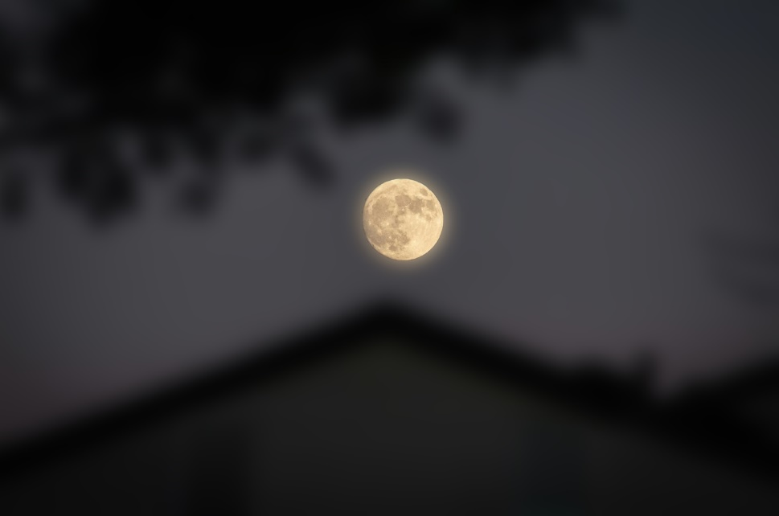

**Assignment 8:**

Place an image inside a text and apply multiple effects on the text like stroke, drop shadow, bavel emboss, gradient overlay. (need before after for each effects)

Before image:



Steps:

* Open the image
* Select the text tool
* Make text box
* Type a text according to your choice
* Set the text size, align, change font, color if needed.
* Select image layer (marked as background), Go to layer option, go to new, select layer from background, Set the background image as layer0.
* Now, go to layers list and drag the text layer below the layer0 (image layer) to get the image behind the text.
* Right Click on layer0 (image layer) and select “set clipping mask”.
* Select text layer.
* Go to “add layer style” (bottom right, fx) and add styles to the text.

After image (image as text background):



After image (stroke):



After image (drop shadow):

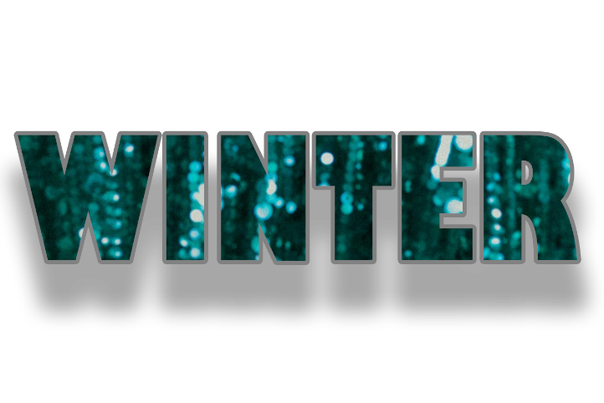

After image (bavel emboss):

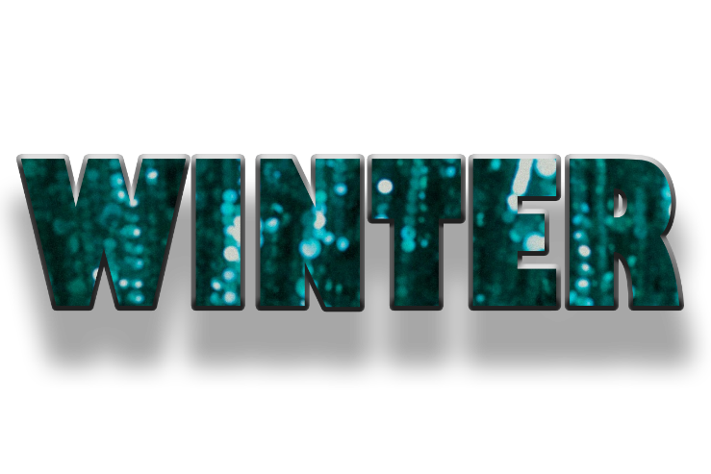

After image (gradient overlay):

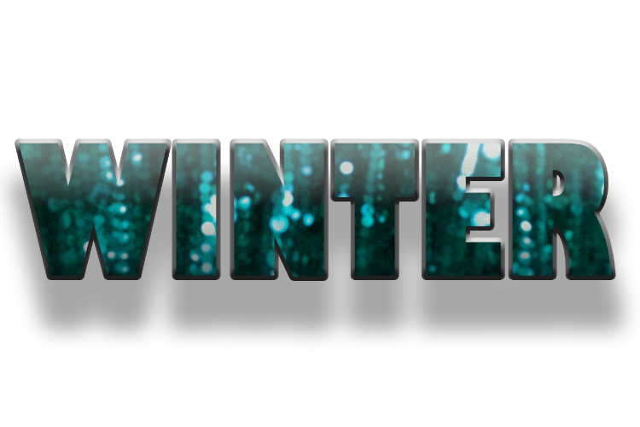

**Assignment 9:**

Create a black and white background of a color image.

Before image:

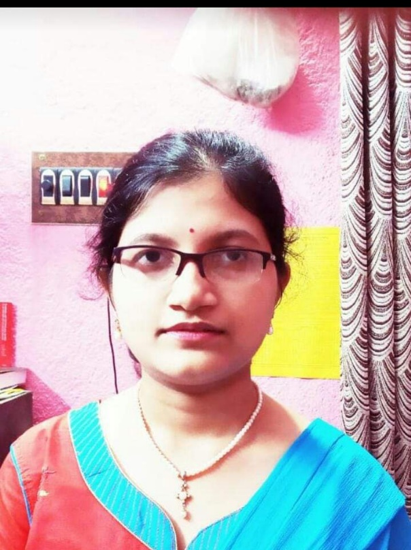

Steps:

* Open an image.
* Select Quick Selection Tool (left menu list) and use it to select the fore ground.
* Use “Brush +”, “Brush -“ and “Brush size selector” opetions of Quick Selection Tool (top menu list) to respectively select, deselect portion of image and change brush size.
* After the image is selected, Right Click on the image and select “Select Inverse”, to select the back ground.
* Go to Image -> Adjustments -> Black & White, a pop up box opens.
* Adjust the colors (if needed) and click OK.
* Right Click on the image and select “Deselect”.
* Save your master piece.

After image:

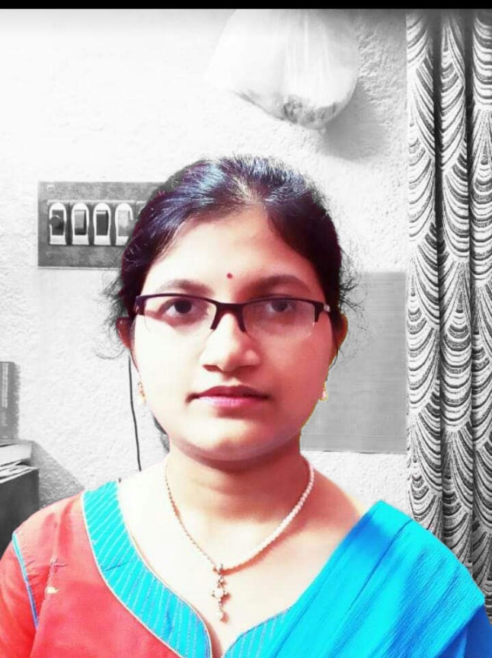

**Assignment 10:**

Use mosaic filter on the image.

Before image:



Steps:

* Open the image.
* Goto filter, select Pixelate, select Mosaic.
* Set cell size, ok.

After image:

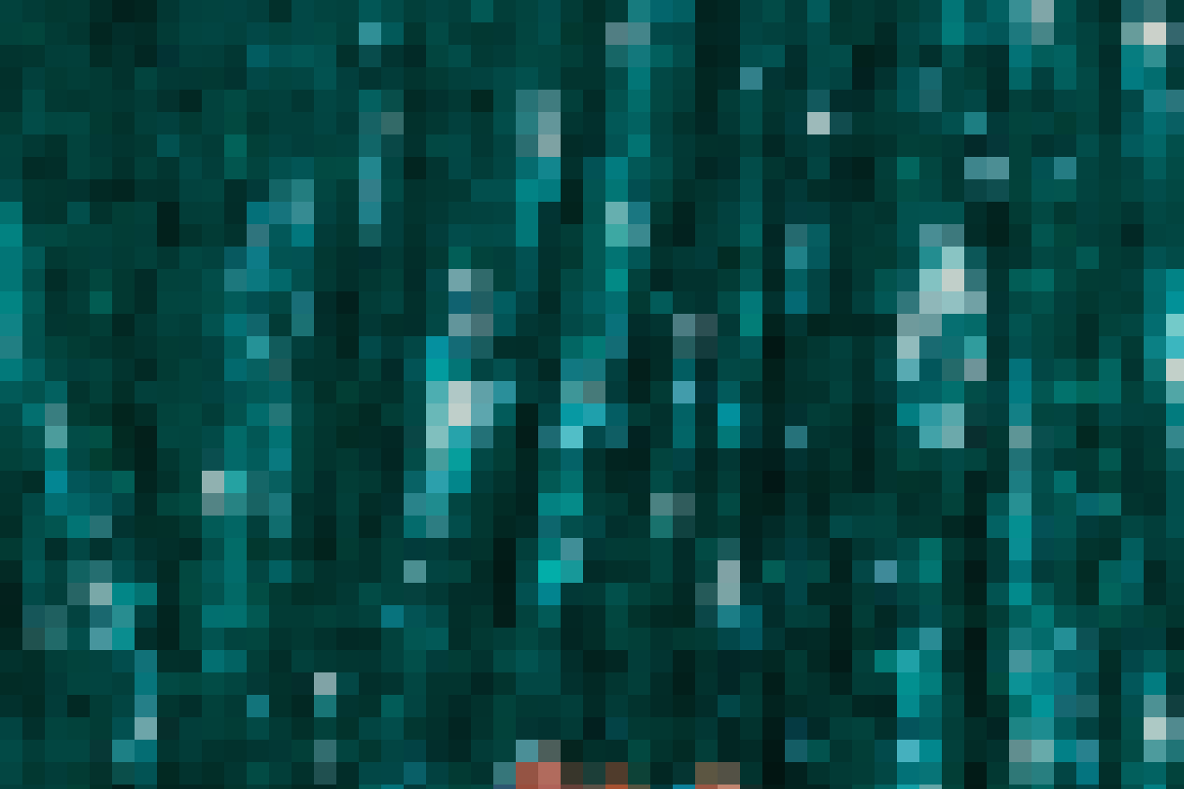

**Assignment 11:**

Add a frame to the image.

Before image:

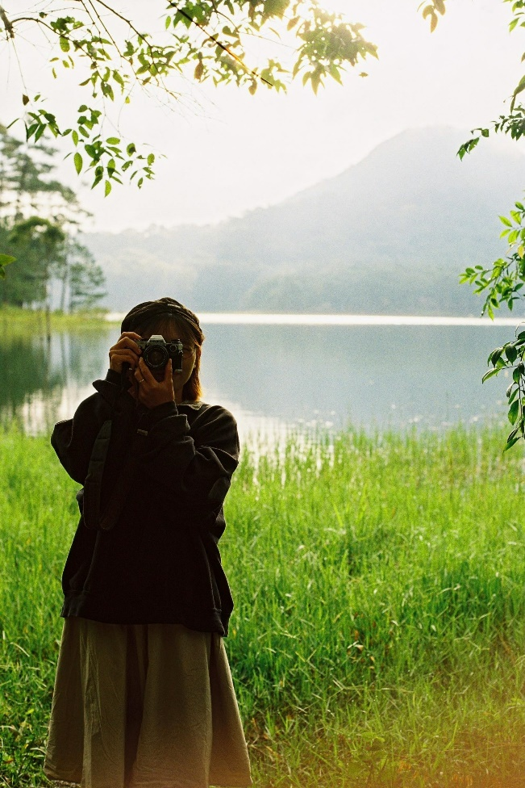

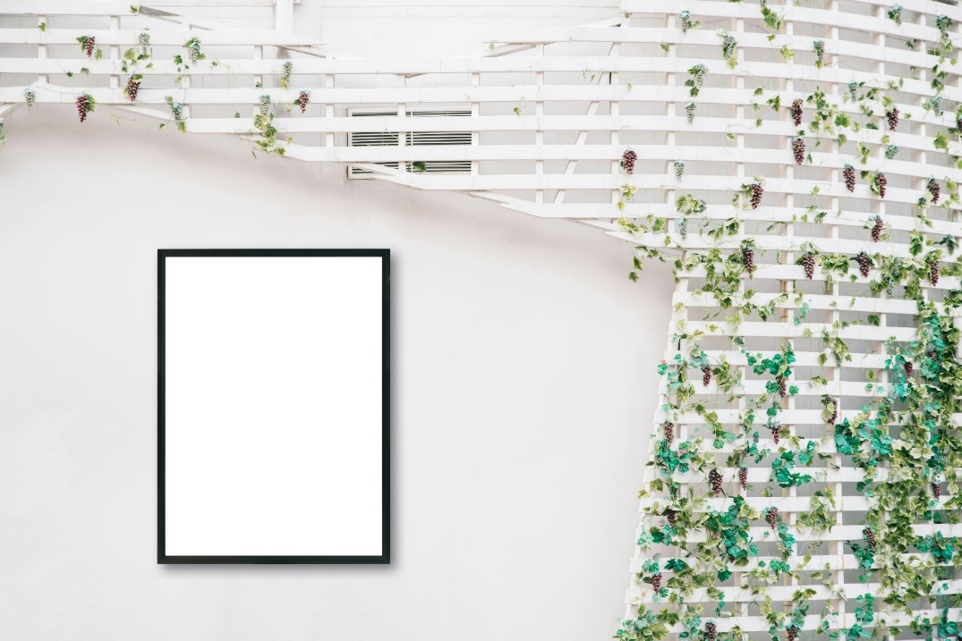

Steps:

* Open the frame and the image.
* Crop the image to fit it into the frame, if needed.
* Select the image by move tool and drag it on the frame tab and place it on top the frame area, it will become a new layer, say “layer1”.
* Select layer1 (the image layer).
* Select “Rectangular Marquee Tool” and right click on the image and select free transform.
* Change the image size as needed to fit the image or its desired portion inside the frame.
* Select background layer, and turn off the visibility of layer 1 or image layer.
* Use magic wand to select the area of the frame where we put the image.
* After selection, make layer 1 visible (without selecting it), to get a preview of how much image falls in selected area on the frame.
* Go to select -> modify, use contract or expand to contract or expand the selected frame area, to fit the image properly into the frame.
* Select layer1 (image layer) and click on “add layer mask” (bottom right).
* Save your master piece.

After image:

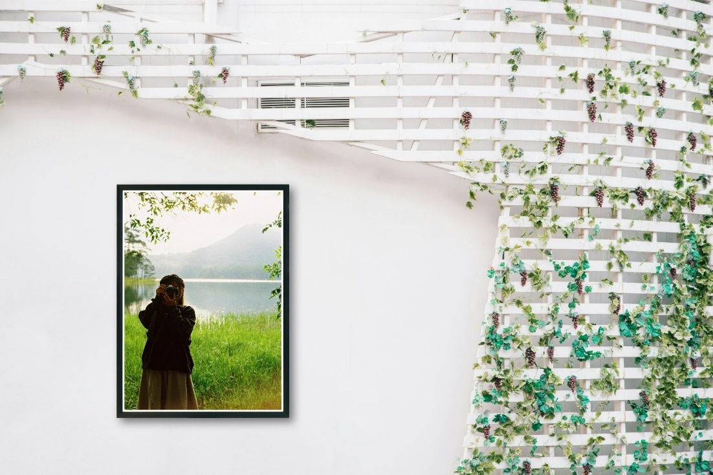

**Assignment 12:**

Create a banner design for cultural program of your college.

Before image:

    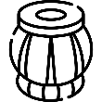  

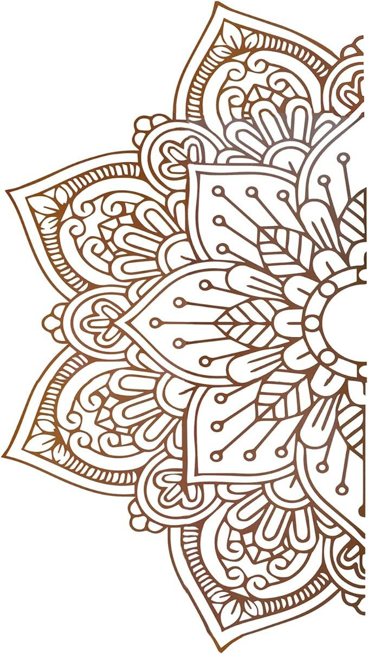

Steps:

* Open these images.
* Create a new image or canvas where the banner will be designed.
* Select **Background Layer** and change its color using the steps below**:**
  + Select the “**Rectangular Marquee Tool**” and press **Ctrl + a** to select the whole image.
  + Right click on the selected area, select “**Fill**”, in “**Use**” tab select “**Color**”. And keep Blending Mode “**Normal**” and Opacity “**100%**”. Click Ok.
  + Right click on the selected area, and select “**Deselect**”.
* Create **Layer 1:**
  + Use “**Rectangle Tool**” to create a rectangle as a border. This will create a new layer.
  + Right click on the layer in the layers tab and select the option to rasterize it.
* Create **Layer 2:**
  + Copy the icons of musical instruments and paste it in the canvas.
  + Select **Rectangular Marquee Tool**, right click on the pasted pattern, select **Free Transform** in the drop down menu, to resize the pattern and place it in the proper position in the image. ‘Move Tool’ can also be used to move it.
  + Repeat step 1 and 2, several times to create several layers to place these icons in several different positions and color them as necessary with “**Paint Bucket Tool**”.
  + After the icons are placed properly combine these layers to create a single layer containing all these icons is several different places.
* Create **Layer 3 (**background pattern)**:**
  + Open the pattern.
  + Use the “**Color Range**” option under “Select” tab to select the white portion.
  + Right click on the selected area, select “**Select Inverse**” to select the pattern without the background.
  + Right click on the selected area, select “**Fill**”, in “**Use**” tab select “**Black**”. And keep Blending Mode “**Normal**” and Opacity “**100%**”. Click Ok.
  + Copy the pattern and place it in the banner canvas as a new layer, adjust its position and opacity.
* Now arrange the layers as **Layer 1** (top) => **Layer 2** => **Layer 3** => **Background Layer** (bottom).
* Add some text and decorate them. And add the final icons around the text.

After image:

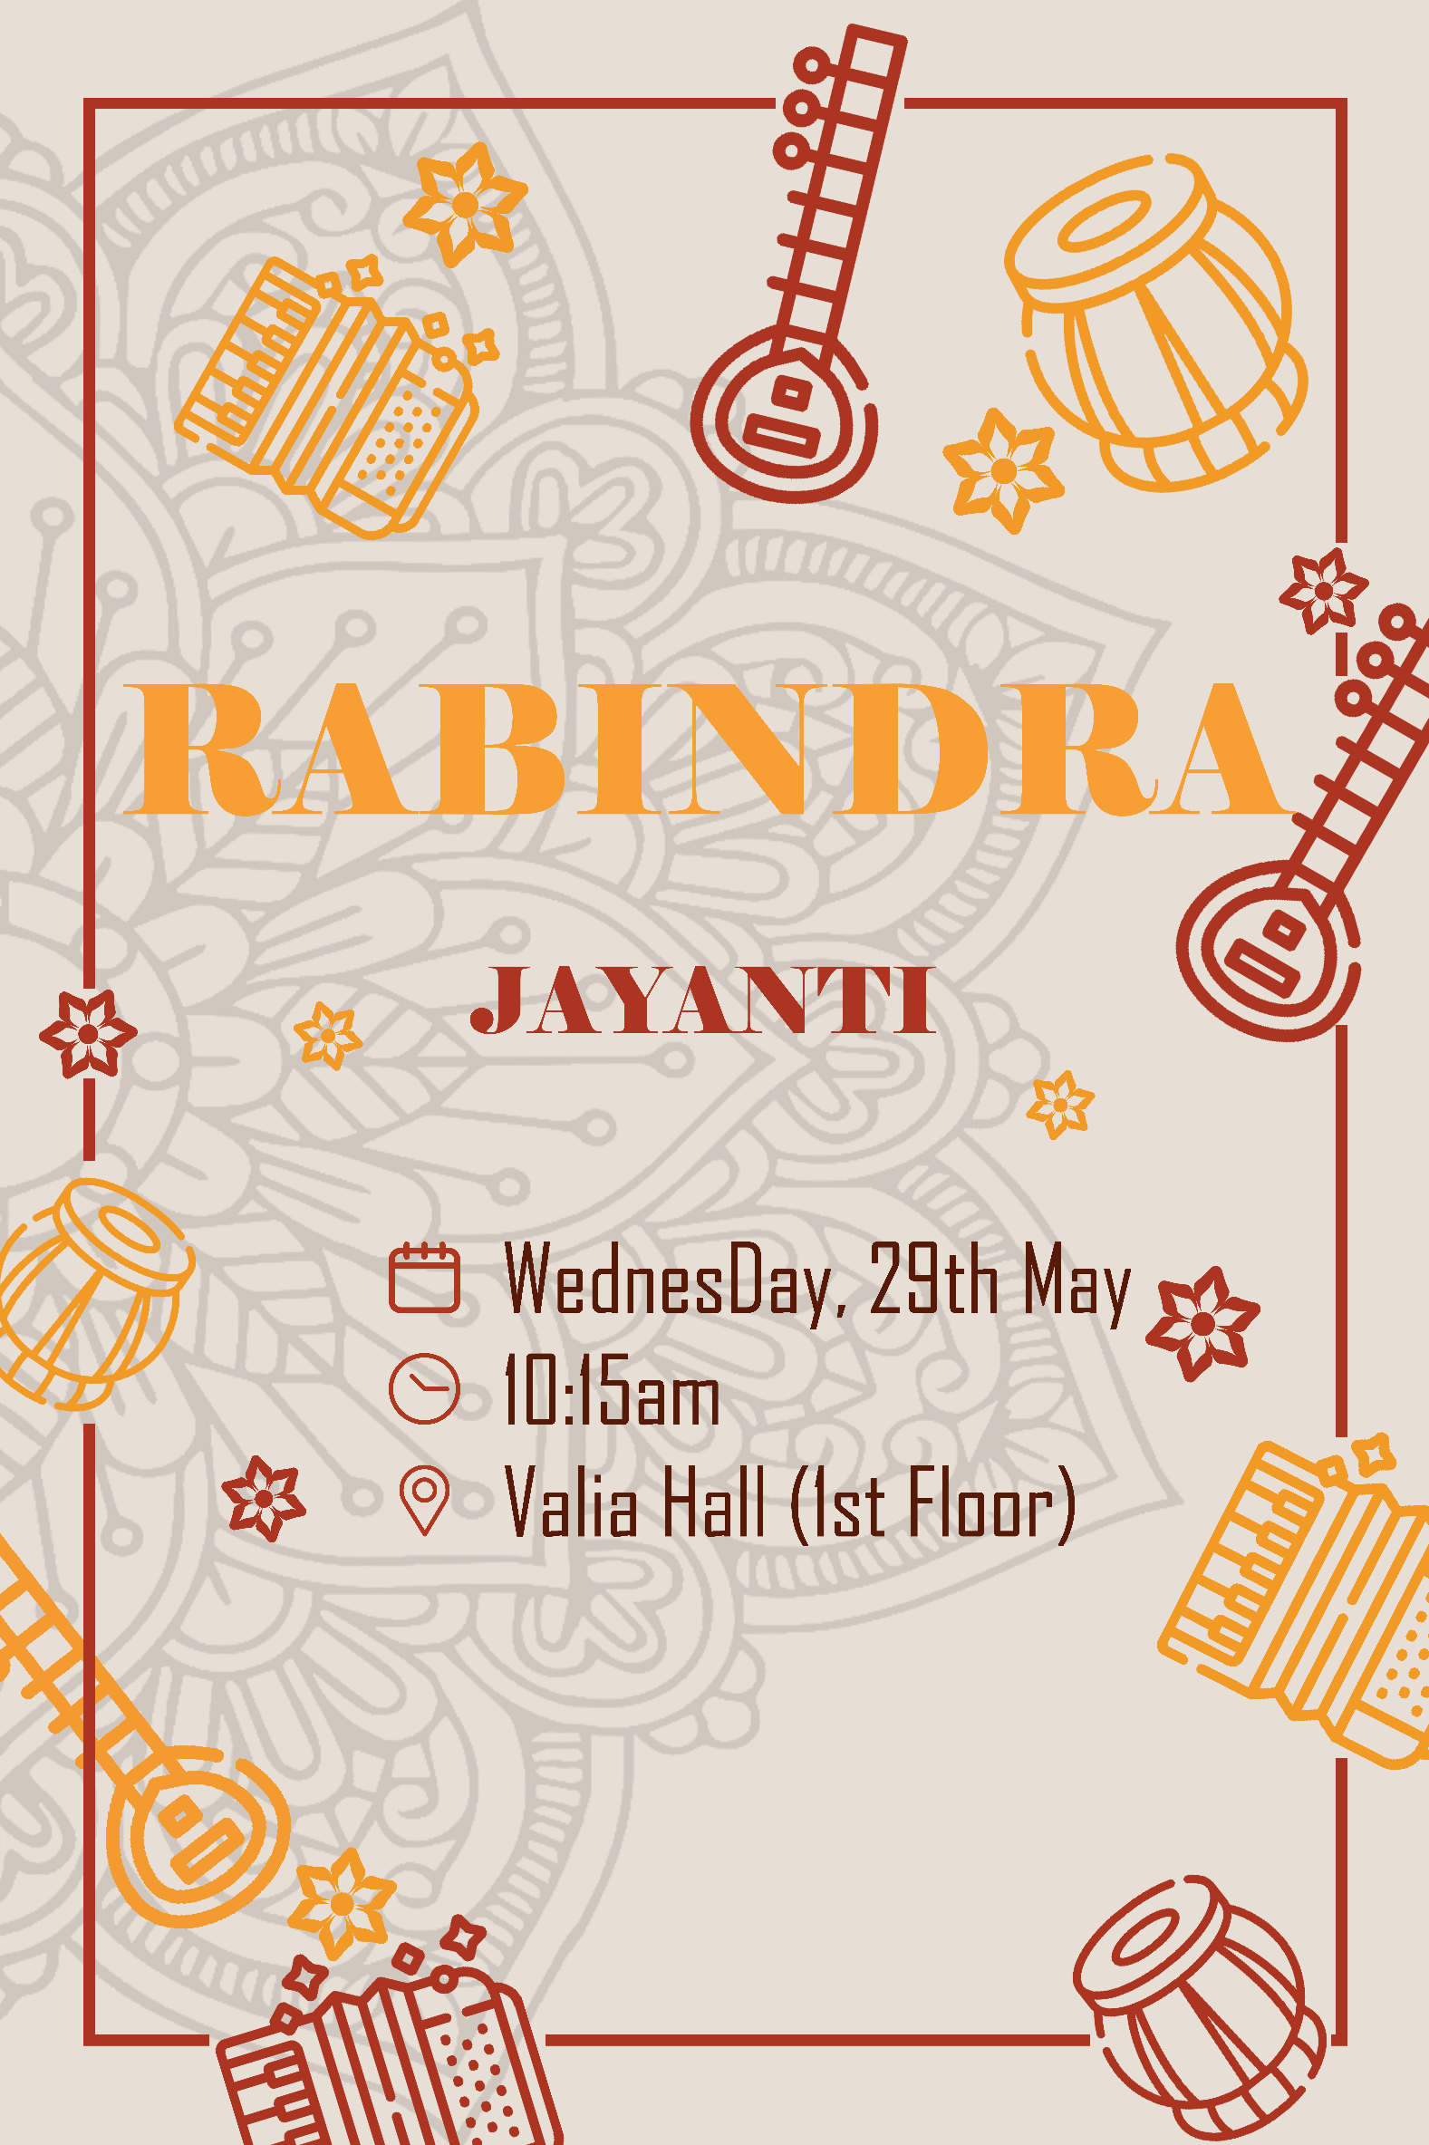

**Assignment 13:**

Create a flex design for swaraswati puja of your college.

Before image:

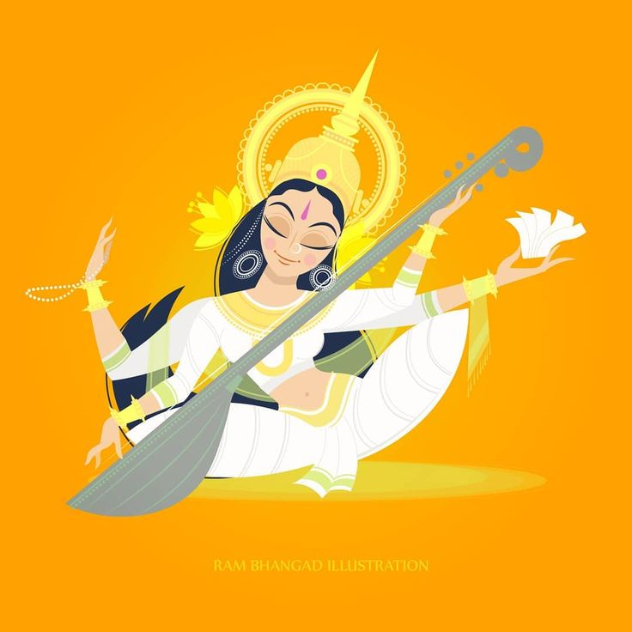

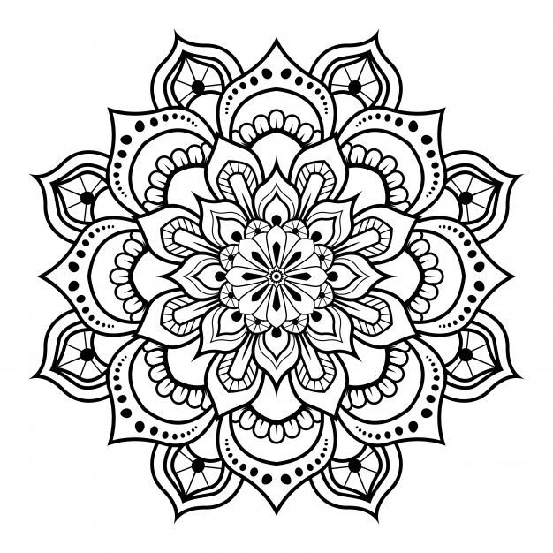

Steps:

* Open these images.
* Create a new image or canvas where the banner will be designed.
* Create **Layer 1:**
  + Copy Goddess and paste it in the new canvas and layer 1 is created.
  + Select the empty (white) part of the layer with **Rectangular Marquee Tool**, right click on the selected area, select **Fill…** in the drop down menu, use the background color of the Goddess to fill this area. Hence, entire layer has same background.
* Create **Layer 2:**
  + Copy the pattern and paste it in the new canvas and a new layer is created.
  + Select **Rectangular Marquee Tool**, right click on the pasted pattern, select **Free Transform** in the drop down menu, to resize the pattern and place it in the proper position in the image. ‘Move Tool’ can also be used to move it.
  + Repeat step 1 and 2, 4 times to create 4 layers to place this pattern in 4 different positions.
  + After the patterns are placed properly combine these layers to create a single layer containing this pattern is 4 different places.
* Create **Layer 3: (**This layer is created as I want to keep some of the patterns beyond the picture of the goddess)
  + Using **Magic Wand Tool** select the background of the Goddess from **Layer 1**, right click on selected area, select, **Select Inverse** from the drop down menu. Thus, the image of Goddess is selected.
  + Copy the image of goddess and paste it as **Layer 3**.
  + Now remove as much of the remaining background visible as possible, by selecting them with either **Color Range** option under **Select** tab or **Quick Selection Tool** and deleting the selected pixels with **Del key**.
* Now arrange the layers as **Layer 3** (top) => **Layer 2** => **Layer 1** (bottom).
* Add some text and decorate them with Yellow shadow, using **Drop Shadow** option of **Layer Styles** tab.

After image:

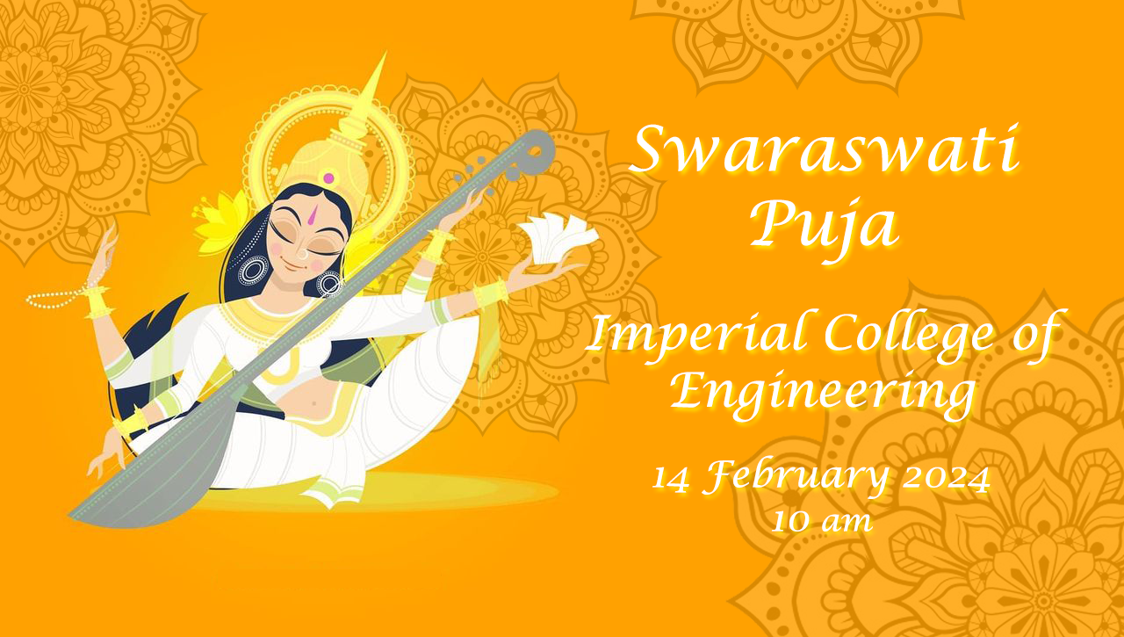

**Assignment 14:**

Create a visiting card design.

Before Image:

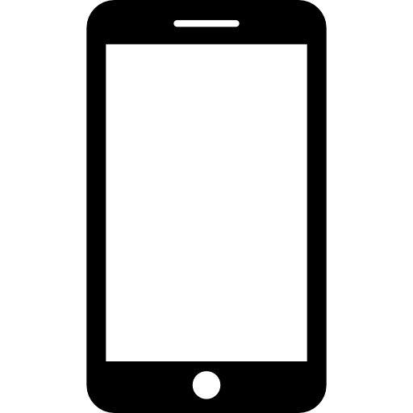

Steps:

* Open these images.
* Create a new image or canvas where the banner will be designed.
* Select **Background Layer** and change its color using the steps below**:**
  + Use “**Rectangular Marquee Tool**” to select some parts of the image.
  + Right click on the selected area, select “**Fill**”, in “**Use**” tab select “**Color**”. And keep Blending Mode “**Normal**” and Opacity “**100%**”. Click Ok. Or, use “**Paint Bucket Tool**” to color selected areas.
  + Right click on the selected area, and select “**Deselect**”.
* Create **Layer 1:**
  + Use “**Rectangle Tool**” and “**Ellipse Tool**” to create the shapes that will contain personal details like email, address, phone etc. This will create a new layer for each shape.
  + After the all the shapes are made properly, Right click on the layers in the layers tab and select the option to rasterize it and marge them all into a single layer.
* Create **Layer 2:**
  + Copy the icons of web, phone, location, settings and email, and paste it in the canvas.
  + Select **Rectangular Marquee Tool**, right click on the pasted pattern, select **Free Transform** in the drop down menu, to resize the pattern and place it in the proper position in the image. ‘Move Tool’ can also be used to move it.
  + Repeat step 1 and 2, several times to create several layers to place these icons in several different positions and color them as necessary with “**Paint Bucket Tool**”.
  + After the icons are placed properly combine these layers to create a single layer containing all these icons is several different places.
* Now arrange the layers as **Layer 2** (top) => **Layer 1** => **Background Layer** (bottom).
* Add some texts and decorate them as necessary.

After Image:

